**Signature Dermatology**

**Spring Events Calendar 2016**

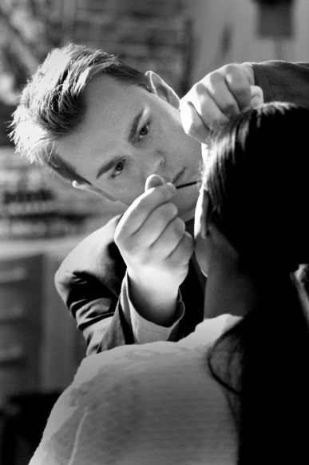

**Friday, March 18**

**Join International Makeup artist, Mr. Tim Maurer in a private**

***Spring Fling***

**makeup session.**

**By appointment only**

**11am-5pm**

**Call 614-777-1200 to schedule**

**Revision Skincare will provide free skin care consultations and 20% off all day**

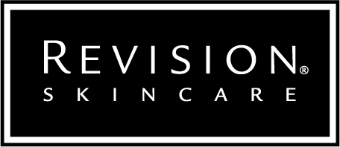

**One-on-one makeup sessions by appointment only.**

**10% off Mukha purchases!**

**Thursday, April 7**

**9am-5pm**

Join us for a Radiance Peel party with Obagi Medical. We will be providing free consultations and $15 off the Obagi Radiance Peel. Don’t worry, there’s no down time after the treatment, just glowing skin! Book your consult and treatment, this is by appointment only.

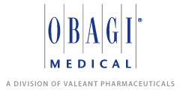You will receive 50% off your Tretinoin and free travel sized cleanser and toner when you purchase a Nu-Derm Transformation System through April.

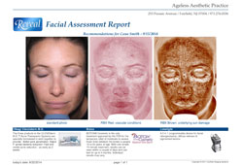**Friday, April 29**

**9am-5pm**

Not sure which peel is for you?

This is the perfect time to find out.

Visit with Jennifer from Glytone who

will use the Reveal Skin Imaging camera

to assess sun damage, dark spots, red spots,

and more.  By appointment only.

**May**

All month enjoy 20% off Glytone Peels (or 10% off packages) in preparation for summer fun!  A full range of chemical exfoliations are available to refresh the skin. All skin types can benefit from a Glytone peel: oily, dry, acne, sun-damaged, and even rosacea! Schedule your treatment for the month of May for this special savings.

**June**

Sunscreen Sale!! Stock up all month on sunscreen for your summer outdoor activities with 15% off Elta MD and Blue Lizard.

Gift Cards are available in our office for cosmetic services and products!

Mother’s Day in May Father’s Day in June

Don’t forget the grads!

