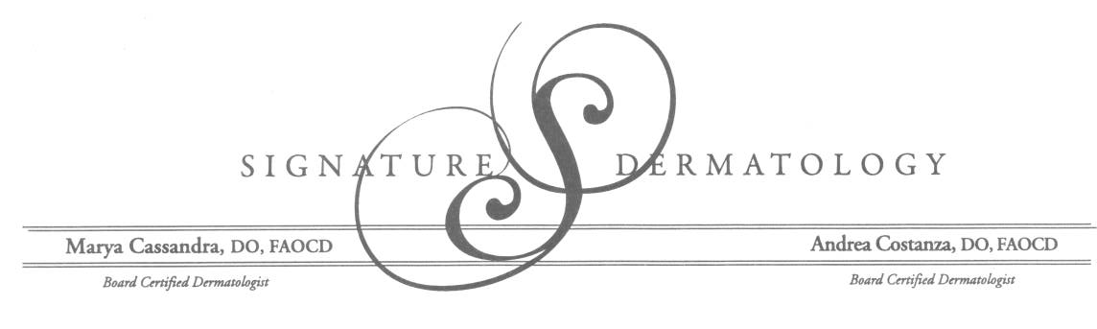

**AUTHORIZATION FOR RELEASE OF MEDICAL INFORMATION**

Patient Name : _________________________________ DOB : ___ / ___ / ___

Address : _____________________________________ SS : _____ -_____ - _____

City/ State / Zip Code: __________________________________________________________

Phone Number : ( ____ ) ______ - __________

**REQUEST AND AUTHORIZE:**

Name: _________________________________ of __________________________________

Address : _____________________________________

City/ State / Zip Code: __________________________________________________________

Phone Number : ( ____ ) ______ - __________ / Fax Number : ( ____ ) ______ - __________

**To release health care information of the patient named above to:**

Signature Dermatology, LLC

3853 Trueman Court

Hilliard, Ohio 43026

Phone: 614-777-1200 / Fax: 614-777-1294

**This request and authorization applies to: (Check One)**

Health care information relating to the following treatment, condition,

Or dates of treatment: _______________________________.

Most Recent Bloodwork  Pathology Report(s) for : ______________________

Other _____________________________________________________________________________

**Signature of patient or patient’s authorized representative Date**

X____________________________________________________________________________________